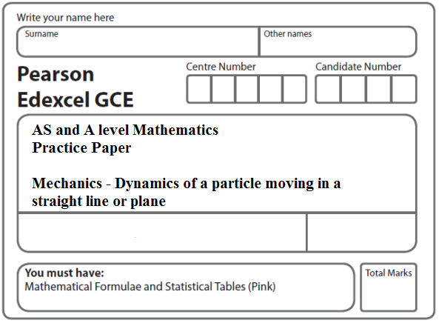
Instructions
- Use black ink or ball-point pen.
- If pencil is used for diagrams/sketches/graphs it must be dark (HB or B).
- Fill in the boxes at the top of this page with your name, centre number and candidate number.
- Answer all the questions and ensure that your answers to parts of questions are clearly labelled.
- Answer the questions in the spaces provided – there may be more space than you need.
- You should show sufficient working to make your methods clear. Answers without working may not gain full credit.
- Inexact answers should be given to three significant figures unless otherwise stated.
Information
- A booklet ‘Mathematical Formulae and Statistical Tables’ is provided.
- There are 5 questions in this question paper. The total mark for this paper is 40.
- The marks for each question are shown in brackets – use this as a guide as to how much time to spend on each question.
Advice
• Read each question carefully before you start to answer it.
• Try to answer every question.
• Check your answers if you have time at the end.
• If you change your mind about an answer, cross it out and put your new answer and any working underneath.
1.

A vertical rope AB has its end B attached to the top of a scale pan. The scale pan has mass 0.5 kg and carries a brick of mass 1.5 kg, as shown in Figure 1. The scale pan is raised vertically upwards with constant acceleration 0.5 m s^{–2} using the rope AB. The rope is modelled as a light inextensible string.

(a) Find the tension in the rope AB.
(3)
(b) Find the magnitude of the force exerted on the scale pan by the brick.
(3)
(Total 6 marks)
___________________________________________________________________________

2. A woman travels in a lift. The mass of the woman is 50 kg and the mass of the lift is 950 kg. The lift is being raised vertically by a vertical cable which is attached to the top of the lift. The lift is moving upwards and has constant deceleration of 2 m s^{–2}. By modelling the cable as being light and inextensible, find
(a) the tension in the cable,
(3)
(b) the magnitude of the force exerted on the woman by the floor of the lift.
(3)
(Total 6 marks)
___________________________________________________________________________

3. A car of mass 1000 kg is towing a caravan of mass 750 kg along a straight horizontal road. The caravan is connected to the car by a tow-bar which is parallel to the direction of motion of the car and the caravan. The tow-bar is modelled as a light rod. The engine of the car provides a constant driving force of 3200 N. The resistances to the motion of the car and the caravan are modelled as constant forces of magnitude 800 newtons and R newtons respectively.
Given that the acceleration of the car and the caravan is 0.88 m s^{–2},
(a) show that R = 860,
(3)
(b) find the tension in the tow-bar.
(3)
(Total 6 marks)
___________________________________________________________________________

4.
Figure 3
A vertical light rod PQ has a particle of mass 0.5 kg attached to it at P and a particle of
mass 0.75 kg attached to it at Q, to form a system, as shown in Figure 3. The system is
accelerated vertically upwards by a vertical force of magnitude 15 N applied to the particle
at Q. Find the thrust in the rod.
(Total 6 marks)
___________________________________________________________________________

5.
Figure 4
Three particles A, B and C have masses 3m, 2m and 2m respectively. Particle C is attached to particle B. Particles A and B are connected by a light inextensible string which passes over a smooth light fixed pulley. The system is held at rest with the string taut and the hanging parts of the string vertical, as shown in Figure 4. The system is released from rest and A moves upwards.
(a) (i) Show that the acceleration of A is .
(ii) Find the tension in the string as A ascends.
(7)
At the instant when A is 0.7 m above its original position, C separates from B and falls away. In the subsequent motion, A does not reach the pulley.
(b) Find the speed of A at the instant when it is 0.7 m above its original position.
(2)
(c) Find the acceleration of A at the instant after C separates from B.
(4)
(d) Find the greatest height reached by A above its original position.
(3)
(Total 16 marks)

TOTAL FOR PAPER: 40 MARKS

